
Special Educational Needs (SEN) Information Report 2025-26
Key Information  Principal: Mr Andrew Tilley  SENCo: Mrs Catherine Feane  SEND Governor: Mr Simon Wilkinson  Dudley Local Offer: DudleyCI | 
Vision

At Ham Dingle Primary Academy, our commitment to inclusivity and aspiration places students and parents at the heart of our collaborative efforts. We work together to create a learning environment that supports all students, in reaching their full potential. By removing educational barriers, providing a stimulating curriculum, and prioritising equity, accessibility, and excellence, we foster the potential for every student to thrive.

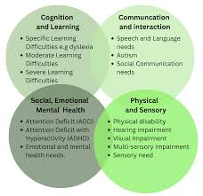
Context
Which types of need are supported at Ham Dingle Primary Academy?
As of September 2025, Ham Dingle Primary Academy has 331 students on roll, of which 11 have an Education, Health and Care Plan (EHCP) and 44 have SEND Support (K).

Glossary
SEMH: Social Emotional Mental Health
C&L: Cognition and learning
C&I: Communication and interaction
S&P: Sensory and physical

 | C&I | C&L | SEMH | S&P | EHCP | Boys | Girls | TOTAL
Rec | 1 | 0 | 2 | 0 | 1 | 2 | 1 | 3
Year 1 | 5 | 0 | 0 | 0 | 2 | 2 | 3 | 5
Year 2 | 3 | 1 | 1 | 3 | 2 | 5 | 3 | 8
Year 3 | 3 | 1 | 3 | 0 | 1 | 7 | 0 | 7
Year 4 | 4 | 1 | 5 | 0 | 4 | 6 | 4 | 10
Year 5 | 3 | 3 | 4 | 1 | 1 | 5 | 6 | 11
Year 6 | 4 | 7 | 0 | 0 | 0 | 5 | 6 | 11
TOTAL | 23 | 13 | 15 | 4 | 11 | 32 | 23 | 55

At Ham Dingle Primary Academy, the most common types of need for those with an EHC plan are SEMH, ASC/ADHD and for those with SEN support is Communication and Interaction needs, specifically those with speech and language needs. Overtime there has been an increase in pupils being diagnosed with a specific learning difficulty.

Local and National Picture
 | Ham Dingle Primary Academy September 2025 | Dudley Local Authority | National Statistics 2024/25 (Primary)
Students with an EHCP | 3.3% | 3.3% | 3.5%
SEND Support | 15.7% | 14.4% | 14.8%

Admissions
How do students with SEND get a place at Ham Dingle Primary Academy?
Please see link to Dudley Admissions

Students with an EHCP
- If your child has an EHCP, this will be reviewed annually. If your child is in Year 5, your preferred secondary school will be discussed at their annual review. The SENCo at Ham Dingle Primary Academy will invite other agencies to attend your child’s annual review at Year 5 to understand more about your child’s needs and how they could be supported.
- You can specify your preferred secondary school as part of the annual review process and this will be sent to Dudley Local Authority SEND team who confirm your admissions request has been approved via the release of an amended EHCP.

Students with special educational needs without an EHCP
No student will be refused admission to Ham Dingle Primary Academy based on his or her special educational needs. In line with the Equality Act 2010, we will not discriminate against disabled children in respect of admissions for a reason related to their disability.

Where Dudley Local Authority proposes to name Ham Dingle Primary Academy in an EHCP, made in accordance with section 324 of the Education Act 1996, the school will be sent a consultation and will outline whether the student’s needs can be met and whether a place will be offered or not. If it is deemed that it would be incompatible with the provision of efficient education for other children, this will be outlined in the consultation response to the Local Authority.

Ham Dingle Primary Academy will admit any child in whose EHCP it has been appropriately named. In deciding whether a child’s inclusion would be incompatible with the efficient education of other children, the school will have regard to the relevant guidance issued by the Secretary of State to maintained schools.

Ham Dingle Primary Academy welcomes any requests to visit our site to ensure we can meet individuals’ needs (with advice as necessary from health professionals on suitability).

Identification
How are special educational needs identified at Ham Dingle Primary Academy?
The SEND Code of Practice (2014) states: ‘A pupil has SEN where their learning difficulty or disability calls for special educational provision, namely provision different from or additional to that normally available to pupils of the same age. Making higher quality teaching normally available to the whole class is likely to mean that fewer pupils will require such support. Such improvements in whole-class provision tend to be more cost effective and sustainable.’

Upon entry to Ham Dingle Primary Academy (or on request from a parent or staff member), we assess each student's skills, building on information from previous settings and key stages where appropriate. At the same time, Ham Dingle Primary Academy will consider evidence that a student may have a disability under the Equality Act 2010 and, if so, what reasonable adjustments may need to be made for them.

Only medical professionals will make formal diagnosis of any SEN in all areas of need – screening tools, assessments and observations will be used to support referrals where necessary, but staff at school should not indicate traits or offer any potential diagnoses.
What assessments are used at Ham Dingle Primary Academy to identify SEN?
Assessments may include:
- Standardised test results
- Reading and numeracy ages
- Reading and comprehension skills
- Working memory
- Boxall Profile / Strengths and Difficulties Questionnaire (SDQ)
- Input from external professionals (e.g. educational psychologists, speech and language therapists, CAMHS)
- Assessments by class teachers identifying students with:
- Significantly slower progress compared to their peers
- Failure to match or exceed previous progress
- Failure to bridge the attainment gap with peers.

What would not constitute SEN?
Drawing on guidance from the SEND Code of Practice (2014):
- Persistent disruptive or withdrawn behaviours do not necessarily mean that a young person has SEN. If it is thought housing, family or other domestic circumstances may be contributing to the presenting behaviour a multi-agency approach, supported by the use of approaches such as the Early Help Assessment, may be appropriate.
- Low attainment or slow progress do not necessarily mean that a student has SEN. In deciding whether to make special educational provision, the teacher and SENCO should consider all of the information gathered from within the school about the student’s progress, alongside national data and expectations of progress.
- Difficulties related solely to limitations in English as an additional language are not SEN.
- Professionals should also be alert to other events that can lead to learning difficulties or wider mental health difficulties, such as bullying or bereavement. Such events will not always lead to young people having SEN but it can have an impact on wellbeing and sometimes this can be severe. Schools should ensure they make appropriate provision for a student’s short-term needs in order to prevent problems escalating.
- The Department for Education publishes guidance on managing pupils’ mental health and behaviour difficulties in schools Mental health and behaviour in schools Ham Dingle Primary Academy has a Senior Mental Health Lead and a Mental Health Lead.

What should I do if I am concerned that my child has SEN?
- Parents know their children best and it is important that we listen and understand when parents express concerns about their child’s development.
- In the first instance, parents should have a conversation with their child’s class teacher. Parents can email the SENDCo catherine.feane@hamdingleprimary.co.uk requesting to book a call to discuss their concerns.
- The first response to such concerns should be high quality teaching targeted at the child’s areas of weakness. Where progress continues to be less than expected the teacher, working with the SENCo, will assess whether the child has SEN. While informally gathering evidence (including the views of the pupil and their parents) Ham Dingle Primary Academy will not delay in putting in place extra teaching or other interventions designed to secure better progress, where required.

Ham Dingle’s Neurodevelopmental Assessment Pathway
Neurodevelopment is a term that refers to the brain's development of systems or networks. It influences an individual’s performance or functioning. Our performance or functioning may include our ability to learn something new, our reading skills, our social skills, our memory skills or our attention or focussing skills.

What does neurodivergent mean?
Neurodivergent describes differences in learning from what is considered typical patterns of development. It is often used when describing a child, young person or adult who may have a particular way or learning. Often people with a diagnosis such as Autism, Attention Deficit Hyperactive Disorder or Developmental Language Disorder may describes themselves as neurodivergent.

When might a young person need a neurodevelopmental assessment?
Neurodevelopmental needs are common. Figures can vary but it is estimated that around 10% of the population have a neurodevelopmental need. Not all children and young people will however need an assessment. Children and young people do not need a diagnosis to access support. Settings must do all they can to meet the special educational needs of the children and young people who attend the setting.

Referring to a specialist assessment pathway should not be the first step in supporting a child/young person. An initial period of observations, information gathering and support should be put in place in line with a graduated response. Consideration should be given to a child or young person's needs both at home and in their setting. An example below is shown of how school might prepare resources and presentations to adapt for specific neuro-diverse needs:

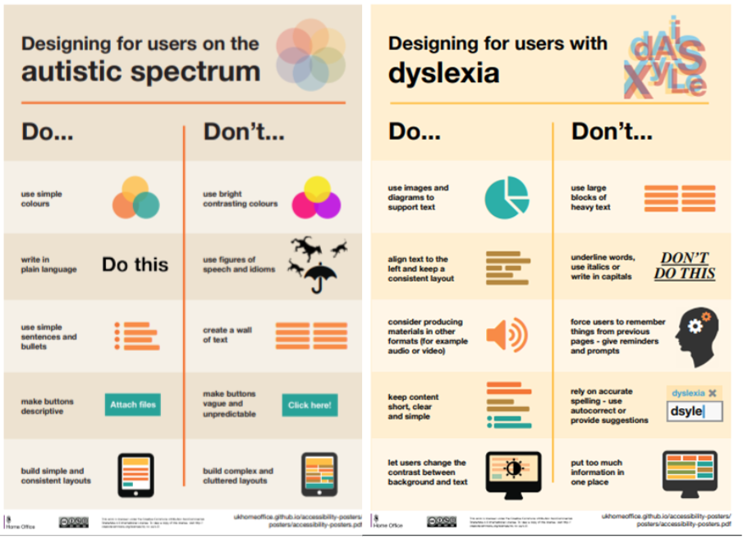

Please carefully consider why you feel a request for a neurodevelopmental assessment is required. You should be able to clearly explain your reasons for the request, what support your child has accessed and what you (and the school) will continue to do to support your child whilst waiting for an assessment or undergoing the assessment process.

Getting Help
Dudley Local Offer (Information, Advice and Support)

The Graduated Approach

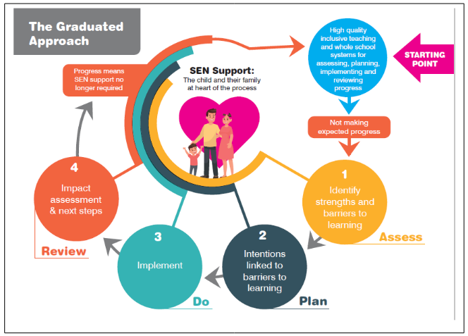

For more information on the Graduated Approach, please see the video: https://youtu.be/Dm7w04UsrUk
What are Ham Dingle Primary Academy’s arrangements for assessing and reviewing students’ progress towards outcomes?
Where a student is identified as having SEN, Ham Dingle Primary Academy will take action to remove barriers to learning and put effective special educational provision in place. This will include looking at the Ordinarily Available Provision in place. This SEN support will take the form of a four-part cycle through which earlier decisions and actions are revisited, refined and revised with a growing understanding of the student’s needs and of what supports the student in making good progress and securing good outcomes. This is known as the graduated approach.

Assess
- The SENCo will carry out a clear analysis of the student’s needs, in partnership with other staff within the Academy.
- The views of parents, the student and, if relevant, advice from external support services will also be shared.
Plan
- All teachers and support staff who work with the student will be made aware of the student’s needs, the support provided and any teaching strategies that are required. This information will be recorded on a One Page Profile (see below) and an Individual Target Plan:

This is a document which captures all the important information about a pupil on a single sheet of paper under simple headings. These are stored in the classroom for quick reference in the Class Family folder so they can be quickly and easily accessed by all teaching, supply and support staff helping meet pupils identified needs effectively.

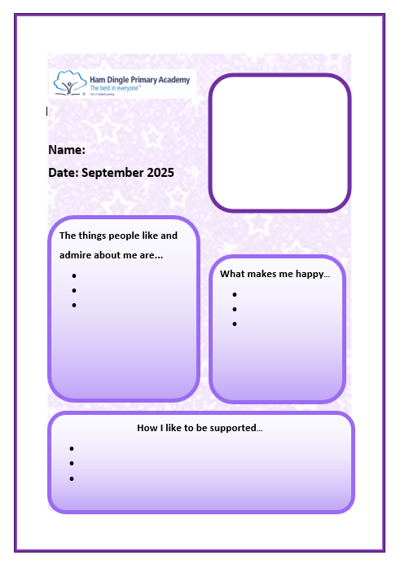

- Parents will be fully aware of the planned support and will receive a copy of their child’s plan.
- Ham Dingle Primary Academy ensures that all students have access to a broad and balanced curriculum. Subject Leaders make sure that their schemes of learning are adapted for students with SEN.
- Individual teachers (under the guidance of Subject Leaders, where necessary) will plan lessons to address potential areas of difficulty and to remove barriers to student achievement.
Do
- The student’s teachers remain responsible for working with the child on a daily basis.
- Where the student has interventions that involve group or one-to-one teaching away from the main class, the teacher and SENCo will monitor the impact of this support and how the learning can be linked to classroom teaching.
- See also our ‘Interventions Offer’ below.
Review
- After a period of weeks (on the date agreed), the impact of the support will be evaluated against student progress.
- A review will take place through a discussion with parents, the teacher and student, in addition this may include the key worker TA and the SENCo.
- The teacher will revise the support in light of the student’s progress, deciding on any changes to the support in agreement with the parent and student.
- Where a student continues to make less than expected progress, despite support and interventions, the SENCo will seek further advice and involve specialists (e.g. educational psychologist, speech and language therapist, CAMHS, specialist teachers, occupational therapist) where appropriate. The student’s parents will always be involved in any decision to involve specialists.
- Where a student has an EHC plan, the local authority must review that plan as a minimum every twelve months.

Whole school evaluation of SEND provision
- Ham Dingle Primary Academy makes data on the levels and types of need within the school available to the local authority collected through School Census.
- The SENCO has an important role to play with the headteacher in working with the governing body to determine and evaluate the strategic development of SEN policy and provision in the school.
- Ham Dingle Primary Academy works closely with the trust’s (United Learning) regional SEND Adviser to audit provision and access further support and advice as required.
- The Trust (United Learning) are working with Whole Education to enhance the leadership of SEND.

Requesting an Education, Health and Care needs assessment
Where, despite the school having taken relevant and purposeful action to identify, assess and meet the SEN of the young person, the young person has not made expected progress, the school or parents can request an Education, Health and Care needs assessment. To inform its decision the local authority will expect to see evidence of the action taken by the school as part of the graduated approach.

What does work for SEND?
Research shows these 5 approaches add maximum value for learners with SEN. They are relatively easy to adopt and add into practice. They benefit all learners, not just those with SEN.

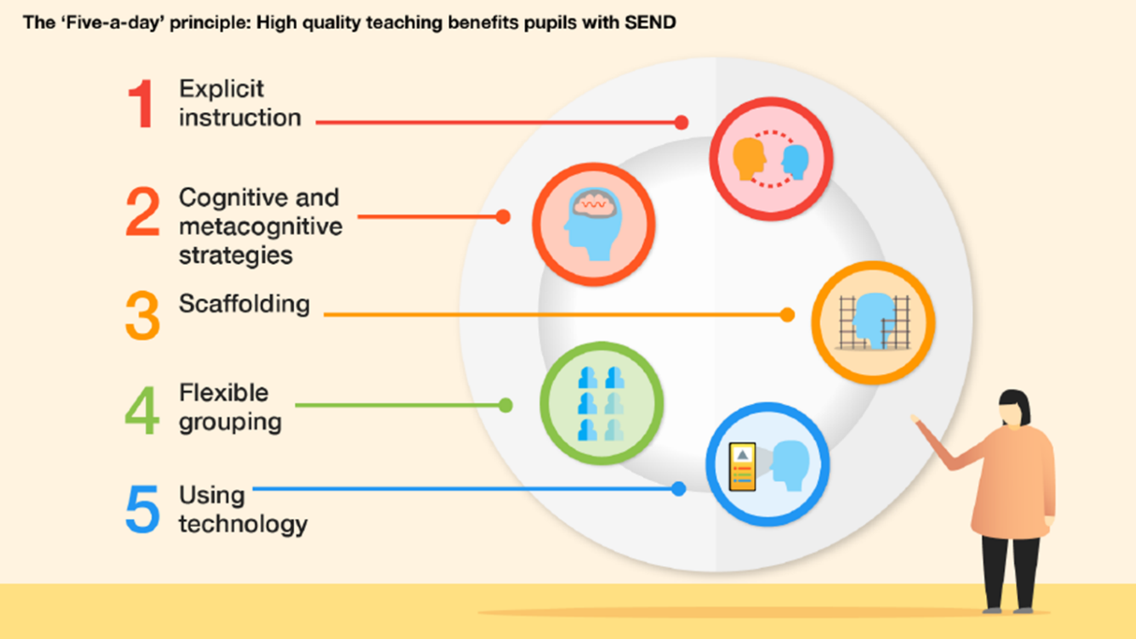
Further information can be found on the following link – Supporting SEND in the Classroom

Interventions Offer at Ham Dingle Primary Academy
These include an exit criteria in the form of a SMART target. These are tracked over a six week period with a mid-point and end point review. They are also evaluated termly to assess the impact on pupil learning.
- Precision Teaching
Used 1:1 for pupils with specific needs who require repeated practice of key skills.
- PIRA Reading and White Rose Maths Interventions
Targeted individual and group intervention activities for the areas of weakness demonstrated in your pupils’ diagnostic test results in reading and maths.
- NESSY – Reading and Spelling
A structured Literacy intervention based upon the Science of Reading. The program begins with systematic synthetic phonics and advances to instruction in spelling, morphology, vocabulary and comprehension.
- Reading Support
An individual tracking of reading to develop pace and fluency.
- WELLCOMM
Used to develop language skills and communication.
- Speech & Language
Individual targets from SALT.
- RWi Phonics Tutoring
Focused catch-up support to get pupils reading fast.
- Working Memory
An intervention to support recall and retrieval skills for pupils who struggle to retain knowledge.
- Get Moving and Funky Fingers
An intervention to support gross and fine motor skill development.
- Sensory Circuits
An intervention to support regulation of sensory needs.
- Conscious Discipline
A whole school intervention to support SEMH needs.
- SEND Continuum
An intervention with tracking to support progress in English and Maths skills.
- Nurture Provision
A whole school intervention to support SEMH and social skill needs.

Exam Access Arrangements
At Ham Dingle Primary Academy we ensure that students who require extra support in tests receive this. This is based on diagnostic testing as well as collating evidence of a history of need and a pupil’s normal way of working. It will very often be stated in reports from external agencies e.g. Visual Impairment
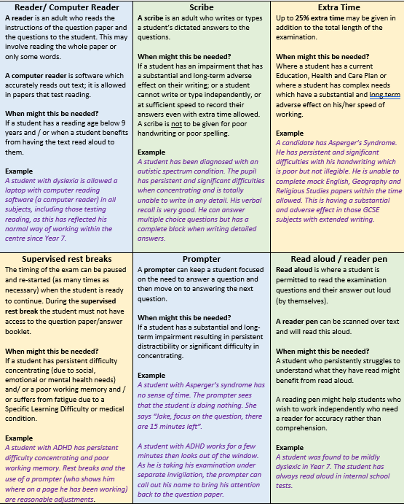


Social, Emotional and Mental Health Provision
Ham Dingle Primary Academy’s Senior Mental Health Lead is Catherine Feane, and our additional Mental Health Lead is Shelley Whitmore. All staff are trained in Conscious Discipline. At Wave 1 it provides an array of behaviour management strategies for classroom structures that teachers can use to turn everyday situations into learning opportunities. Conscious Discipline encompasses the following components:
Wave 1 - useful link: Conscious Discipline Methodology - Conscious Discipline
Wave 2 – useful link: BBC Tiny Happy People
Anna Freud - Mentally Healthy Schools
Wave 3 – useful link: SDQ Strengths and Difficulties Questionnaire
Boxall Profile The Boxall Profile - Nurture UK

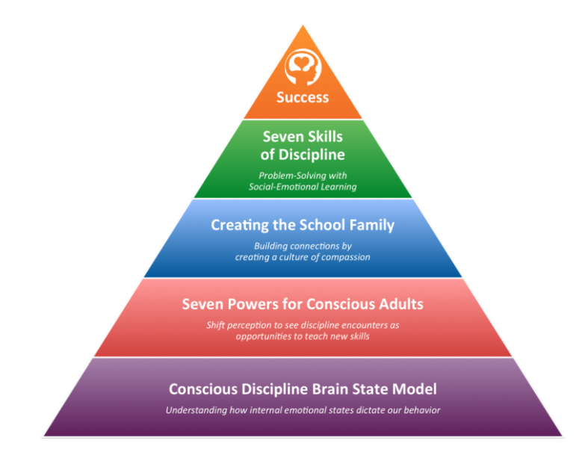
Belonging
How are students with SEND encouraged to take part in the wider school offer and learning opportunities?
At Ham Dingle Academy, we foster a culture of developing the ‘whole child’, providing opportunities, which will inspire, excite and prepare students for the future.

Extra-Curricular Offer
Ham Dingle Primary Academy offers an array of clubs including sports, performing and creative clubs. The timetable undergoes adjustments each term, ensuring students can access a variety of different experiences at lunchtime and after school. Recognising the unique needs of students with SEND, our dedicated staff provide tailored support to plan their involvement in these extra-curricular activities, this can include the additional nurture offered in our lunchtime games and learning support with homework support in After School Club. The Academy is committed to proactively addressing any potential barriers to ensure every student can fully engage and benefit from the diverse opportunities offered.

Charter and Rewards
The Academy vision is to personally develop all students, to produce responsible, respectful and active citizens who are able to play their part and become actively involved in public life as adults. We are proud of our commitment to deliver outstanding Education with Character.

To support this vision, the Academy pledges to provide leadership, careers, social and cultural opportunities for all our students. Students can earn Bronze, Silver and Gold Jass Awards, which are awarded annually. Students also get an opportunity to be rewarded and recognised by showcasing their endevours at our weekly VIP assembly. The SENCo and staff endeavour to ensure that students with SEND are always represented and included in all aspects of leadership, as well as being recognised for their fantastic contributions to our community.

Parent and Student Voice
How are students and families included in decision making?
- Annual online United Learning Survey for parents and students
- Termly parent’s evenings and sharing of Individual Target Plans
- Termly SEND coffee afternoons for parents
- Dedicated SEND student voice activities e.g. One Page Profiles, annual reviews
Transition
What additional support can students with SEND benefit from at key transition points?

Primary School Transition
- Targeted visits and planning with secondary school SENCOs and Y7 teachers to ensure a smooth handover of key information
- Targeted visits to provider nursery
- Professionals meeting with all agencies around the child
- Additional visits to setting e.g. stay and play

Training
What training do staff undertake at Ham Dingle Primary Academy to support students with SEND?

Available to all staff:
- September INSET: whole school SEND systems, student transition & access arrangements
- De-escalation planning supporting students with SEND
- Tailored SEND briefings (as needed in response to key themes or challenges)
- Solution focused sessions/observations facilitated by the Educational Psychologist and / or SENCo for identified students / areas of need.
- Emotion Coaching and Conscious Discipline
- Trauma informed approach to supporting behaviour
- Exam reader pens training
- Precision teaching
- Neuro diverse conditions
- Speech and Language Needs e.g. Wellcomm

Subject Leaders:
- Subject specific curriculum adaptations for students with SEND
- SENCo and Subject Leaders joint learning walks, book looks and SEND student voice.
Impartial Information and Advice
SENDIASS
SENDIASS is a free, dedicated, confidential and impartial service offering a single point of regular and consistent contact. SIASS can explain how special educational needs are identified and assessed and who you should talk to. We can also tell you what your rights and responsibilities are.

SENDIASS can offer support with:
- arranging or attending meetings with school, the local authority, health/social services or other agencies
- writing letters and reports
- the council's processes for resolving disagreements and its complaints procedures
- Contact either by email dudley.sendiass@dudley.gov.uk
or by contacting the office mobiles 07900 161363 or 07929 777744

Communication and Complaints Process
Stage 1
Ham Dingle Primary Academy aim to deal with all matters of concern raised by parents promptly, fairly, openly, and without prejudice. In the first instance, parents are encouraged to discuss their concerns with the SENCo. These concerns can be made in writing and emailed to catherine.feane@hamdingleprimary.co.uk or you can arrange a call or an in-person meeting with the SENCo by calling 01384 900 753
The SENCo will aim to resolve matters at Stage 1 within 15 working days.

Stage 2
If parents are not satisfied with the response at Stage 1, the complaint can be escalated to formal Stage 2 procedures. Stage 2 complaints should be made to the Head teacher andrew.tilley@hamdingleprimary.co.uk (or the Chair of Governors, Jonathon Wilding, if the complaint concerns the Head teacher, who will investigate and provide a formal response. At Stage 2, the principal or Chair of Governors will acknowledge the complaint in writing within 10 working days (excluding those that fall in the school holidays) of receiving it. The written acknowledgment will, as far as possible, explain how the complaint will be investigated, the timescale for completing any necessary investigation and delivering a response.

If a parent remains dissatisfied with the outcome at Stage 2, please see the Complaints Policy for next steps.

Complaints about Dudley Local Authority
If your complaint is about the Local Authority, for example admissions, EHC assessment requests or reviews, contact can be made following the information on the link below:
Complaints and feedback | Dudley Council

Further Advice

Parents can also contact IPSEA, a charity in the field of SEND law in England. IPSEA provide free and independent legal advice and support to families of children and young people with SEND: https://www.ipsea.org.uk/call-in-helpline

IPSEA also provide lots of useful free guides and resources, including template letters to fit your situation: https://www.ipsea.org.uk/template-letters
Accessibility Plan
Schools need to carry out accessibility planning for disabled pupils (as directed in the Equality Act 2010). This plan must be reviewed at least every three years.

Schools must implement accessibility plans which are aimed at:
- increasing the extent to which disabled pupils can participate in the curriculum;
- improving the physical environment of schools to enable disabled pupils to take better advantage of education, benefits, facilities and services provided; and
- improving the availability of accessible information to disabled pupils.

Useful Policies
Parents may find it helpful to read further information about how Ham Dingle Primary Academy supports students with SEND in the following policies:
- SEND Policy
- Accessibility Plan
- Safeguarding Policy
- Behaviour Policy
All policies are available on the school website: Home (hamdingleprimary.co.uk)

